·:Lpath CONTROLLED FORM I ICOIPOIATID TITLE: GXP and Non-GXP Study Report Review and Approval Form I DOCUMENT NO. VERSION ISSUE DATE EFFECTIVE DATE PAGE I I I GE003FM01 02 17 Oct 2014 20 Oct 2014 2 of2 o vendor Study Protocol O vendor Study Report [{] Lpath Study Report Lpath Study No.: LT 3114-PHA-017 -R Version No.: 0/ ~~Non GXP I=- GLP GCP GMP Product Name: LT 3114 Test Article: 83; L T3114 Study Title: Cell based activity of anti-LPA antibodies, B3 and LT 3114 I I Study Vendor/Site: N/A Study Director: U N/A Study Contributor(s): U N/A LPath Rosalia Matteo Kelli Moreno Vendor Study No.N ersion: [{)NjA Study Dates: Report Date: 2007 Nov 2014 Lab Notebook Reference: LNB#210 pp.24-27; 59; 122-125 QJ/A Executive summary of study results: O see Attached lJNJA A cell based system has been developed to examine LPA receptor activation by various LPA isoforms and also to evaluate the inhibition of signaling by anti-LPA antibodies. Using these assays we have demonstrated that B3 and LT 3114 anti-LPA antibodies were potent in blocking the binding of different LPA isoforms to LPA receptor 1 and preventing its activation. Lt>ATII AI’PROVAL Function Name (Print) Signature Date Study Director/Monitor i2o..so.t;o.. ~cclteo l,~Y?r:tkoJ’. II l1 ~ J..2 o/4 Contributor /tHt ru”#f ~itt /z’!/’~u~ /’7 Research ~ wo6Y~ ~a D .d. tl tt/ I 13 /?.PI t.( I I Development ~ ~fA/li.Jo ~~x- II If ~l’f- Quality Assurance I f E Lv //2 A- J#/1, -eft.//t -i. ~ //.J. c:::>_{.v}V/1/ ~ v Jl ·:LP...~ CONFIDENTIAL
Table (source: module4_extracted/Cell based activity of anti-LPA antibodies, B3 and LT3114/tables/table_page_1_idx_1.csv)
·:Lpath I ICOIPOIATID
CONTROLLED FORM
TITLE: GXP and Non-GXP Study Report Review and Approval Form
None
INO. VERSION ISSUE DATE EFFECTIVE DATE PAGEI I003FM01 02 17 Oct 2014 20 Oct 2014 2 of2
None
Table (source: module4_extracted/Cell based activity of anti-LPA antibodies, B3 and LT3114/tables/table_page_1_idx_2.csv)
o vendor Study Protocol O vendor Study Report [{] Lpath Study Report
None
None
None
None
None
None
None
None
None
Lpath Study No.: LT 3114-PHA-017 -R
None
Version No.: 0/
None
None
~~Non
None
None
I=-
GLP
Product Name: LT 3114
None
Test Article: 83; L T3114
None
None
None
None
None
None
None
Study Title: Cell based activity of anti-LPA antibodies, B3 and LT 3114
None
None
None
None
None
None
None
None
None
I IVendor/Site: N/A Study Director: U N/A Study Contributor(s): U N/ARosalia Matteo Kelli Moreno
None
None
None
None
None
None
None
None
None
[{)NjAStudy No.N ersion:
None
None
Study Dates:
None
None
Report Date:
None
None
None
Lab Notebook Reference: LNB#210 pp.24-27; 59; 122-125 QJ/A
None
None
None
None
None
None
None
None
None
Executive summary of study results: O see Attached lJNJAcell based system has been developed to examine LPA receptor activation by various LPA isoforms and also tothe inhibition of signaling by anti-LPA antibodies. Using these assays we have demonstrated that B3 and anti-LPA antibodies were potent in blocking the binding of different LPA isoforms to LPA receptor 1 andits activation.
None
None
None
None
None
None
None
None
None
Lt>ATII AI’PROVAL
None
None
None
None
None
None
None
None
None
Function
Name (Print)
None
None
Signature
None
None
Date
None
None
Study Director/Monitor
i2o..so.t;o..~cclteo
None
None
l,~Y?r:tkoJ’.
None
None
II l1 ~ J..2 o/4
None
None
Contributor
/tHt
None
None
ru”#f/’7
None
None
~itt /z’!/’~u~
None
None
Research
~ wo6Y~
None
None
D .d. tl~a
None
None
I/ 13 /?.PI t.(
None
None
Development
~ ~fA/li.Jo
None
None
~~x-
None
None
I IIf ~l’f-
None
None
Quality Assurance
E Lv //2 A- J#/1, -eft.//t -i.
None
None
~ //.J.~
None
None
I f:::>_{.v}V/1/
None
None
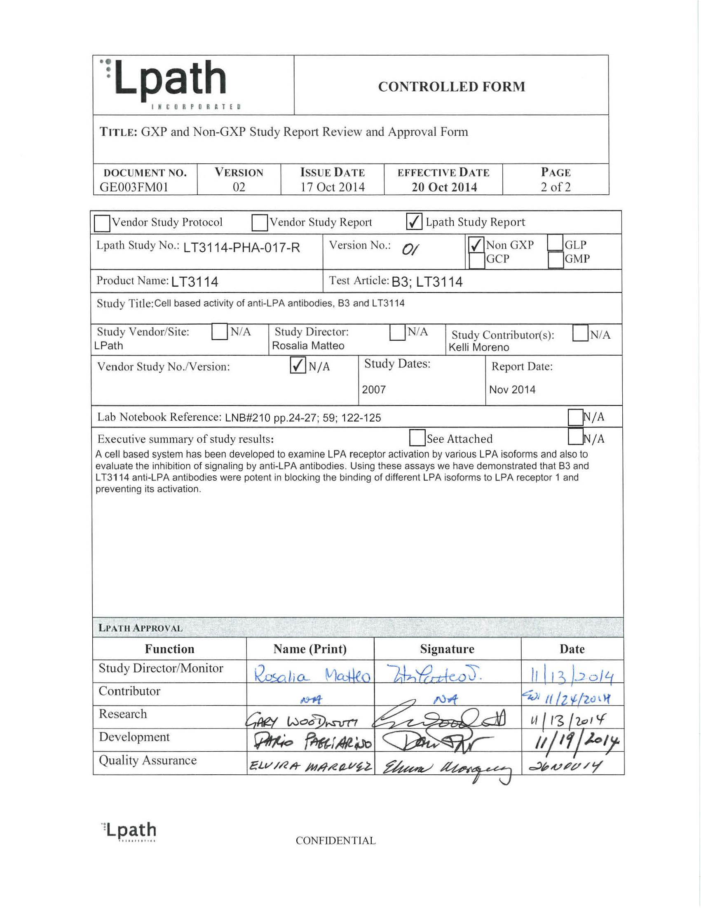
Image page 1 #1
REPORT NUMBER: LT3114-PHA-017-R Title: Cell based activity of anti-LPA antibodies, B3 and LT3114 Page 1 of 9 Cell based activity of anti-LPA antibodies, B3 and LT3114 Document Type Final Repot Study Monitor Rosalia Matteo Study Director Kelli Moreno Performance Site (s) Lpath Initiation Date 2007 Completion Date 2007 Date FSR 10-2014 2014 GLP, GMP or GCP Non-GLP Number of Pages 9 Description Test Article Murine Anti-LPA antibody(B3) and humanized anti-LPA antibody (LT3114) Archive Lpath CONFIDENTIAL
Table (source: module4_extracted/Cell based activity of anti-LPA antibodies, B3 and LT3114/tables/table_page_2_idx_1.csv)
0
1
REPORT NUMBER: LT3114-PHA-017-R: Cell based activity of anti-LPA antibodies, B3 and LT3114
Page 1 of 9
REPORT NUMBER: LT3114-PHA-017-R Title: Cell based activity of anti-LPA antibodies, B3 and LT3114 Page 2 of 9 TABLE OF CONTENTS 1 SUMMARY ………………………………………………………………………………………………………..3 2 INTRODUCTION ……………………………………………………………………………………………….3 3 MATERIALS AND METHODS ……………………………………………………………………………4 3.1 Test Article and Control……………………………………………………………………………….4 3.2 Study Design ………………………………………………………………………………………………4 3.3 Cells ………………………………………………………………………………………………………….4 3.4 Thawing and Maintenance of Cells ……………………………………………………………….4 3.5 Treatment of Cells……………………………………………………………………………………….5 3.6 Data Analysis ……………………………………………………………………………………………..5 4 RESULTS …………………………………………………………………………………………………………..6 5 CONCLUSION ……………………………………………………………………………………………………9 6 DATA ARCHIVE ………………………………………………………………………………………………..9 LIST OF IN-TEXT FIGURES Figure 1 Binding of LPA isoforms to LPAR1 (A), LPAR2 (B) and LPA3 (C) ………7 Figure 2 Inhibition of LPA isoform binding to the LPAR1 receptor by anti-LPA antibodies ………………………………………………………………………………………..8 CONFIDENTIAL
Table (source: module4_extracted/Cell based activity of anti-LPA antibodies, B3 and LT3114/tables/table_page_3_idx_1.csv)
0
1
REPORT NUMBER: LT3114-PHA-017-R: Cell based activity of anti-LPA antibodies, B3 and LT3114
Page 2 of 9
REPORT NUMBER: LT3114-PHA-017-R Title: Cell based activity of anti-LPA antibodies, B3 and LT3114 Page 3 of 9 1 SUMMARY A cell based system has been developed to examine LPA receptor activation by various LPA isoforms and also to evaluate the inhibition of signaling by anti-LPA antibodies. Using these assays we have demonstrated that B3 and LT3114 anti-LPA antibodies were potent in blocking the binding of different LPA isoforms to LPA receptor 1 and preventing its activation. 2 INTRODUCTION Lysophosphatidic acid (LPA) is not a single molecular entity but a collection of structural analogs with a single functional glycerol alcohol phosphate moiety esterified to a variety of fatty acyl hydrocarbons of varied lengths and degrees of saturation. LPA species with both saturated (16:0 and 18:0) and unsaturated fatty acids (16:1, 18:1, 18:2, and 20:4) have been identified in biological fluids with 16:0, 18:1 18:2 and 20:4 LPA being the predominant species. LPA is released during inflammation by multiple cell types and mediates its actions predominantly by interaction with at least five members of the multiple transmembrane G protein-coupled receptor family (GPCR). The receptors are designated LPAR1-5. LPAR1 is expressed in a wide range of organs whereas LPAR2 and LPAR3 show a more restricted profile of expression. Lpath has generated murine and humanized monoclonal antibodies and this report describes data showing that these antibodies bind to isoforms of LPA and prevent the activation of relevant LPA receptors. The data in this report was generated by using PathHunter TM products developed by DiscoveRX (Frenton, CA). Briefly, The PathHunter TM products use Enzyme Fragment Complementation technology in which two weakly complementing fragments of the B- galactosidase (β-gal) enzyme are expressed within stable transfected cells. In this system, one fragment of the β-gal, termed the enzyme acceptor (EA), is fused to the C-terminus of the β- arrestin2. The complementing fragment of β-gal, termed the ProLinkTM tag, is expressed as a fusion protein with the LPA receptor at the C-terminus. Upon activation, the LPA receptor is phosphorylated, providing a binding site for β-arrestin. The interaction of β-arrestin and the LPA receptor forces the interaction of Prolink and EA, thus allowing complementation of the two fragments of β-gal and the formation of functional enzyme capable of hydrolyzing substrate and generating a chemiluminescent signal. Complementation is driven by protein- protein interaction between arrestin-EA and ProLink-labeled LPA Receptor. CONFIDENTIAL
Table (source: module4_extracted/Cell based activity of anti-LPA antibodies, B3 and LT3114/tables/table_page_4_idx_1.csv)
0
1
REPORT NUMBER: LT3114-PHA-017-R: Cell based activity of anti-LPA antibodies, B3 and LT3114
Page 3 of 9
REPORT NUMBER: LT3114-PHA-017-R Title: Cell based activity of anti-LPA antibodies, B3 and LT3114 Page 4 of 9 3 MATERIALS AND METHODS 3.1 Test Article and Control Murine anti-LPA antibody (504B3; B3) Lot # HR101201 Humanized anti-LPA antibody (LT3114) Lot # LP011202 3.2 Study Design Development of cell based assays to demonstrate the ability of anti-LPA antibodies to block specific LPA receptor signaling. 3.3 Cells The CHO-K1 EDG2 (LPA receptor 1; LPAR1), EDG4 (LPA receptor 2; LPAR2) or EDG7 (LPA receptor 3; LPAR3) β-arrestin clones (PathHunterTM) obtained from DiscoveRx (Frenton, CA) were expanded and maintained at Lpath following the manufacturer’s recommendations. Briefly, these clones use Enzyme Fragment Complementation technology in which two weakly complementing fragments of the β-galactosidase (β-gal) enzyme are expressed within stably transfected cells. In this system, one fragment of the β-gal, termed the enzyme acceptor (EA), is fused to the C-terminus of the β-arrestin2. The complementing fragment of β-gal, termed the ProLinkTM tag, is expressed as a fusion protein with the LPA receptor at the C-terminus. Upon activation, the LPA receptor is phosphorylated, providing a binding site for β-arrestin. The interaction of β-arrestin and the LPA receptor forces the interaction of Prolink and EA, thus allowing complementation of the two fragments of β-gal and the formation of a functional enzyme capable of hydrolyzing substrate and generating a chemiluminescent signal. Complementation is driven by the protein-protein interaction between arrestin-EA and ProLink-labeled LPA Receptor. 3.4 Thawing and Maintenance of Cells A frozen vial of EDG cells was thawed in a 37°C water bath under sterile conditions. DMSO was removed by transferring the cells to a sterile 50 mL conical tube with 15 mL of pre- warmed complete media without antibiotics (F12 nutrient mix with (+) L-glutamine supplemented with 10% fetal bovine serum) and centrifuging at 1100rpm for 5 minutes. The supernatant was removed and the cell pellet was resuspended in 5 mL of pre-warmed complete media without antibiotics and transferred to a T150 flask with 25 mL of complete media without antibiotics. The flask was incubated at 37°C in a humidified 5% CO 2 atmosphere. After 24 hours, the media was exchanged with 30 mL of complete growth media with antibiotics (F12 nutrient mix supplemented with 10% fetal bovine serum, 100 U/mL penicillin, 100 µg/mL streptomycin, 292 µg/m L-glutamine, 300 µg/mL hygromycin, and 800 µg/mL G418). Cells were passaged every 2-3 days at a 1:6 dilution in complete growth media with antibiotics using a 0.05% trypsin solution. Cells were maintained at 70% confluence and not allowed to grow at confluence for more than 24 hours. CONFIDENTIAL
Table (source: module4_extracted/Cell based activity of anti-LPA antibodies, B3 and LT3114/tables/table_page_5_idx_1.csv)
0
1
REPORT NUMBER: LT3114-PHA-017-R: Cell based activity of anti-LPA antibodies, B3 and LT3114
Page 4 of 9
REPORT NUMBER: LT3114-PHA-017-R Title: Cell based activity of anti-LPA antibodies, B3 and LT3114 Page 5 of 9 Plating Cells To prepare assay plates, cells were collected into a sterile 50 mL conical tube using 5 mL of a non-enzymatic cell dissociation buffer (CellStripper). Cells were spun at 1100 rpm for 5 minutes, supernatant removed, and the cell pellet was resuspended in 5 mL of complete media with antibiotics. Then the cells were counted using an automated cell counter and plated at 20,000 cells/well (100 µL total volume in each well) in 96-well white clear bottom plates. Plates were incubated at 37°C in a humidified 5% CO2 atmosphere. After 24 hours, plates were starved with OPTI-MEM (reduced serum media with HEPES, 2.4 g/L sodium bicarbonate, and L-glutamine). This was done by quickly and gently dumping the plate upside down to remove media and then adding 100 µL of OPTI-MEM to each well. Plates were incubated at 37°C for another 24 hours. The CHO-K1 EDG2 clone was later adapted to grow in serum free media, thus the serum starvation step was not necessary. 3.5 Treatment of Cells LPA binding curves were prepared by titrating LPA isoforms (0 – 3mM) in OPTI-MEM containing 1 mg/ml BSA onto 2.0 mL deep well plates. The media from a 96-well plate containing the cells was removed and 90 µL of prepared standard (in duplicate) was added to each well. The plates were incubated at 37°C in a humidified 5% CO2 atmosphere for 90 minutes. Plates were then washed with 300 µL of OPTI-MEM. After removal of this wash media by dumping the plate upside down, 100 µL of OPTI-MEM was added to each well. 25 µL of freshly made working detection reagent solution (Cell Assay Buffer, Emerald II, and Galacton Star mixed in a ratio of 19:5:1, respectively) was added to each well. The plates were incubated in the dark at room temperature for an additional 90 minutes. Finally, the plates were read on a standard luminescence plate reader. After defining the binding curves in the presence of varying concentrations of LPA the effect of variation of B3 and LT3114 anti-LPA antibody concentration on the inhibition of LPA isoforms binding to the LPAR1 (EDG2) receptor was examined. Media containing 200 nM of LPA (for 18:1 or 18:2) or 10 mM LPA (for 18:0 or 20:4) and increasing concentrations of B3 or LT3114 (0-1.5 mg/ml) were added to CHO-K1 EDG2 cells and processed as described above 3.6 Data Analysis Data was analyzed using GraphPad Prism 5 software. The standard RLUs were graphed using a four-parameter fit equation. CONFIDENTIAL
Table (source: module4_extracted/Cell based activity of anti-LPA antibodies, B3 and LT3114/tables/table_page_6_idx_1.csv)
0
1
REPORT NUMBER: LT3114-PHA-017-R: Cell based activity of anti-LPA antibodies, B3 and LT3114
Page 5 of 9
REPORT NUMBER: LT3114-PHA-017-R Title: Cell based activity of anti-LPA antibodies, B3 and LT3114 Page 6 of 9 4 RESULTS Binding of LPA isoforms to LPA receptors Figure 1 shows dose response curves for LPA isoforms (16:0, 18:0, 18:1-alkyl, 18:1-acyl, 18:2 and 20:4) binding to the LPA receptor 1 (LPAR1, A), LPA receptor 2 (LPAR2, B) and LPA receptor 3 (LPAR3, C). Inhibition of LPA isoform binding to LPAR1 by anti-LPA antibodies All isoforms of LPA tested showed higher affinity for LPAR1 when compared to LPAR2 and 3 (Figure 1). Thus, the inhibition of binding by the anti-LPA antibodies was tested in the cells over-expressing LPAR1. Figure 2 shows dose dependent inhibition of LPA isoforms (18:0, 18:1,18:2 and 20:4) to LPAR1 and further demonstrates that the murine and human antibodies have similar whole cell activity with respect to LPA signaling through LPAR1. CONFIDENTIAL
Table (source: module4_extracted/Cell based activity of anti-LPA antibodies, B3 and LT3114/tables/table_page_7_idx_1.csv)
0
1
REPORT NUMBER: LT3114-PHA-017-R: Cell based activity of anti-LPA antibodies, B3 and LT3114
Page 6 of 9
REPORT NUMBER: LT3114-PHA-017-R Title: Cell based activity of anti-LPA antibodies, B3 and LT3114 Page 7 of 9 Figure 1 Binding of LPA isoforms to LPAR1 (A), LPAR2 (B) and LPA3 (C) CHO-K1 EDG2 , EDG4 and EDG7 cells were plated and treated as described in materials and methods. LPA curves were prepared by titrating LPA isoforms (0 – 30 µM). CONFIDENTIAL
Table (source: module4_extracted/Cell based activity of anti-LPA antibodies, B3 and LT3114/tables/table_page_8_idx_1.csv)
0
1
REPORT NUMBER: LT3114-PHA-017-R: Cell based activity of anti-LPA antibodies, B3 and LT3114
Page 7 of 9
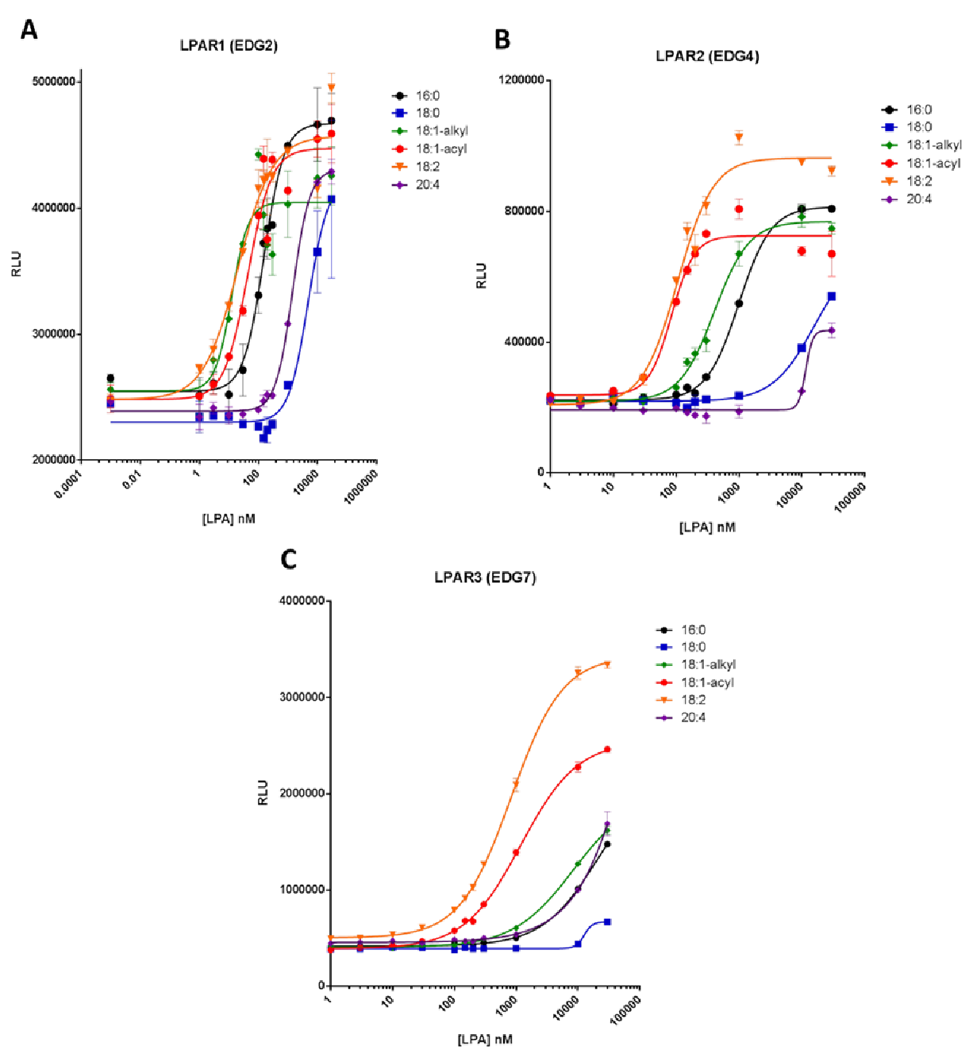
CHO-K1 EDG2 , EDG4 and EDG7 cells were plated and treated as described in materials and methods. LPA curves were prepared by titrating LPA isoforms (0 – 30 µM).
REPORT NUMBER: LT3114-PHA-017-R Title: Cell based activity of anti-LPA antibodies, B3 and LT3114 Page 8 of 9 Figure 2 Inhibition of LPA isoform binding to the LPAR1 receptor by anti-LPA antibodies CHO-K1 EDG2 cells were plated as recommended and starved for 24 h. 200 nM of LPA (for 18:1 or 18:2) or 10 mM LPA (for 18:0 or 20:4) and increasing concentrations of B3 or LT3114 (0-1.5 mg/ml) were added to CHO-K1 EDG2 cells and processed as described in the materials and methods. CONFIDENTIAL
Table (source: module4_extracted/Cell based activity of anti-LPA antibodies, B3 and LT3114/tables/table_page_9_idx_1.csv)
0
1
REPORT NUMBER: LT3114-PHA-017-R: Cell based activity of anti-LPA antibodies, B3 and LT3114
Page 8 of 9
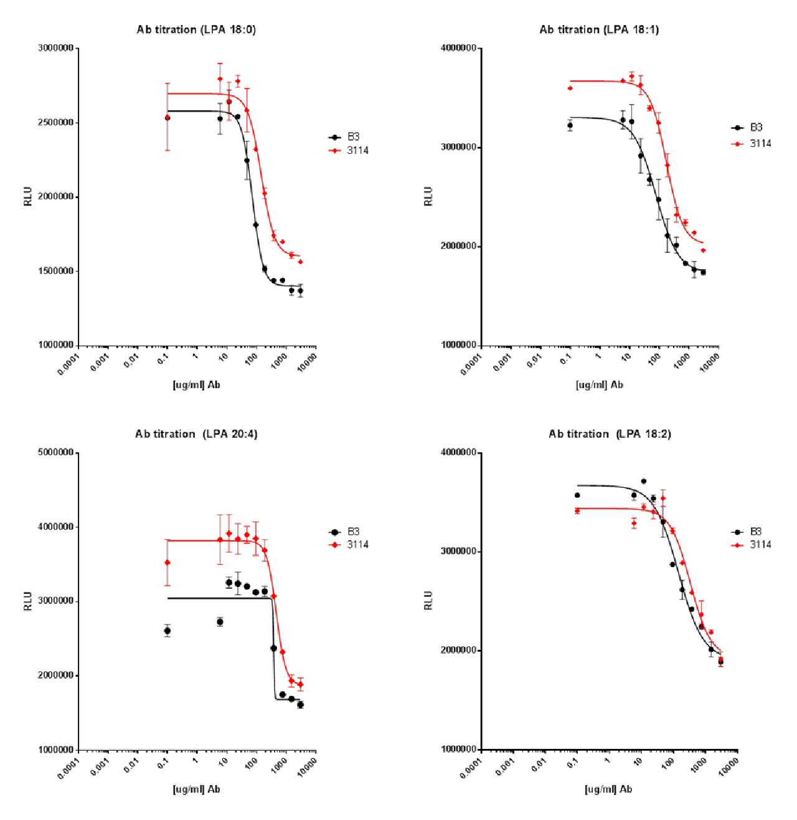
CHO-K1 EDG2 cells were plated as recommended and starved for 24 h. 200 nM of LPA (for 18:1 or 18:2) or 10 mM LPA and increasing concentrations of B3 or LT3114 (0-1.5 mg/ml) were added to CHO-K1 EDG2 cells and (for 18:0 or 20:4) processed as described in the materials and methods.
REPORT NUMBER: LT3114-PHA-017-R Title: Cell based activity of anti-LPA antibodies, B3 and LT3114 Page 9 of 9 5 CONCLUSION We have developed a cell based system to examine LPA receptor activation by various LPA isoforms and also to evaluate the inhibition of signaling by anti-LPA antibodies. Using these assays we have demonstrated that B3 and LT3114 anti-LPA antibodies were potent in blocking the binding of different LPA isoforms to LPA receptor 1and preventing its activation. 6 DATA ARCHIVE Lpath Notebook #210 pp. 24-27; 59; 122-125. CONFIDENTIAL
Table (source: module4_extracted/Cell based activity of anti-LPA antibodies, B3 and LT3114/tables/table_page_10_idx_1.csv)
0
1
REPORT NUMBER: LT3114-PHA-017-R: Cell based activity of anti-LPA antibodies, B3 and LT3114
Page 9 of 9

